**Lecture: Roles - Conditional Execution**

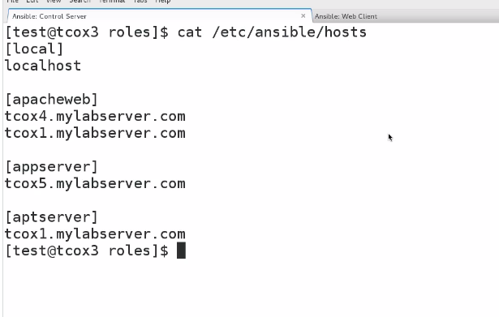

TCOX4 IS CENTOS

TCIX1 IS UBUNTU

EDIT MAIN .YML IN TASK SECTION

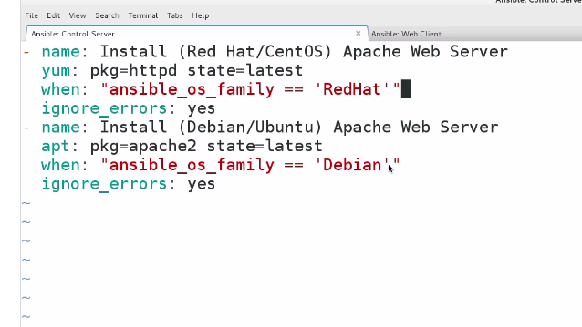

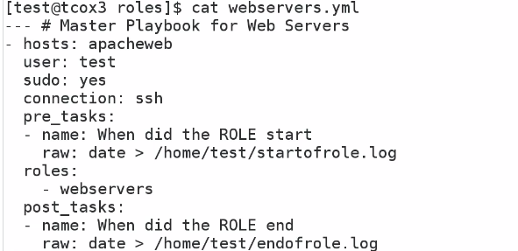

1. Verify that your ansible installation is available by displaying the version of ansible while logged in as the 'user' user.

[test@tcox3 ~]$ ansible --version

ansible 1.9.2

  configured module search path = None

2. Run the ansible command that lists all of the hosts configured in your control server 'hosts' file for the system.

[test@tcox3 ~]$ ansible all --list-hosts

    tcox5.mylabserver.com

    localhost

    tcox4.mylabserver.com

3. Create a master playbook that accomplishes the following:

- Runs against a server/group of servers defined in your hosts configuration

- Runs with the user 'test'

- Executes with 'sudo' privileges

- Includes the 'webservers' role from our previous examples

- Only executes the role if the OS is RedHat or CentOS

[test@tcox3 roles]$ cat webservers.yml

--- # Master Playbook for Web Servers

- hosts: apacheweb

  user: test

  sudo: yes

  connection: ssh

  roles:

  - { role: webservers, when: "ansible_os_family == 'RedHat'" }

4. Run the playbook and display the results

[test@tcox3 roles]$ ansible-playbook webservers.yml

PLAY [apacheweb] **************************************************************

GATHERING FACTS ***************************************************************

ok: [tcox4.mylabserver.com]

TASK: [When did the ROLE start] ***********************************************

ok: [tcox4.mylabserver.com]

TASK: [redhat_webservers | Install (Red Hat/CentOS) Apache Web Server] ********

changed: [tcox4.mylabserver.com]

TASK: [redhat_webservers | shell systemctl status httpd] **********************

changed: [tcox4.mylabserver.com]

TASK: [webservers | debug var=result] **********************************

ok: [tcox4.mylabserver.com] => {

    "var": {

        "result": {

            "attempts": 1,

            "changed": true,

            "cmd": "systemctl status httpd",

            "delta": "0:00:00.007100",

            "end": "2015-11-03 16:04:42.389739",

            "invocation": {

                "module_args": "systemctl status httpd",

                "module_name": "shell"

            },

            "rc": 0,

            "start": "2015-11-03 16:04:42.382639",

            "stderr": "",

            "stdout": "httpd.service - The Apache HTTP Server\n   Loaded: loaded (/usr/lib/systemd/system/httpd.service; disabled)\n   Active: active (running) since Tue 2015-11-03 16:04:39 UTC; 2s ago\n Main PID: 2228 (httpd)\n   Status: \"Processing requests...\"\n   CGroup: /system.slice/httpd.service\n           |-2228 /usr/sbin/httpd -DFOREGROUND\n           |-2229 /usr/sbin/httpd -DFOREGROUND\n           |-2230 /usr/sbin/httpd -DFOREGROUND\n           |-2231 /usr/sbin/httpd -DFOREGROUND\n           |-2232 /usr/sbin/httpd -DFOREGROUND\n           `-2233 /usr/sbin/httpd -DFOREGROUND\n\nNov 03 16:04:39 tcox4.mylabserver.com systemd[1]: Starting The Apache HTTP Server...\nNov 03 16:04:39 tcox4.mylabserver.com systemd[1]: Started The Apache HTTP Server.",

            "stdout_lines": [

                "httpd.service - The Apache HTTP Server",

                "   Loaded: loaded (/usr/lib/systemd/system/httpd.service; disabled)",

                "   Active: active (running) since Tue 2015-11-03 16:04:39 UTC; 2s ago",

                " Main PID: 2228 (httpd)",

                "   Status: \"Processing requests...\"",

                "   CGroup: /system.slice/httpd.service",

                "           |-2228 /usr/sbin/httpd -DFOREGROUND",

                "           |-2229 /usr/sbin/httpd -DFOREGROUND",

                "           |-2230 /usr/sbin/httpd -DFOREGROUND",

                "           |-2231 /usr/sbin/httpd -DFOREGROUND",

                "           |-2232 /usr/sbin/httpd -DFOREGROUND",

                "           `-2233 /usr/sbin/httpd -DFOREGROUND",

                "",

                "Nov 03 16:04:39 tcox4.mylabserver.com systemd[1]: Starting The Apache HTTP Server...",

                "Nov 03 16:04:39 tcox4.mylabserver.com systemd[1]: Started The Apache HTTP Server."

            ],

            "warnings": []

        }

    }

}

TASK: [webservers | debug Need to install telnet] **********************

ok: [tcox4.mylabserver.com] => {

    "msg": "Hello world!"

}

TASK: [debian_webservers | Install (Red Hat/CentOS) Apache Web Server] ********

skipping: [tcox4.mylabserver.com]

TASK: [When did the ROLE end] *************************************************

ok: [tcox4.mylabserver.com]

PLAY RECAP ********************************************************************

tcox4.mylabserver.com      : ok=5    changed=2    unreachable=0    failed=0

